

MATHEMATICS
APPLICATIONS

Test 3 – Recurrence Relationships

Chapter 4
Semester 1 2017

Section One - Calculator Free

Time allowed for this section
Working time for this section: 25 minutes
Marks available: 21 marks

Material required/recommended for this section

To be provided by the supervisor
This Question/Answer booklet
Formula sheet

To be provided by the candidate
Standard items: pens, pencils, pencil sharpener, eraser, correction fluid, ruler, highlighters

Special items: Nil

Important note to candidates
No other items may be used in this section of the examination. It is your responsibility to ensure that you do not have any unauthorised notes or other items of a non-personal nature in the examination room. If you have any unauthorised material with you, hand it to the supervisor before reading any further.

- (6 marks)
The terms of a sequence are shown in the graph below.

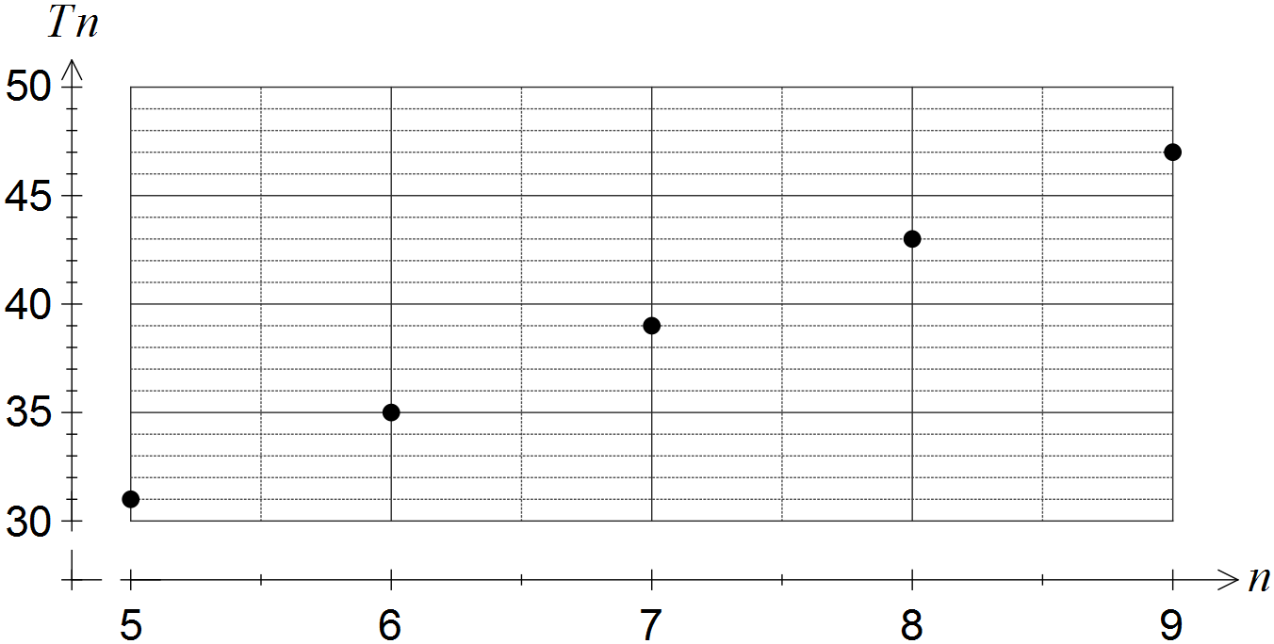

(a) Choose the best description of the sequence from geometric, arithmetic or neither, explaining your choice. [2]

(b) Determine

(i) . [1]

(ii) . [1]

(c) Determine the recursive rule for this sequence. [2]

- (9 marks)
  - A sequence is defined by , where .
    - Determine the next two terms of the sequence. [2]

    - State a rule for the n^{th} term of this sequence. [1]

    - Determine [2]

  - The first-order recurrence relation was used with to calculate and . Determine the values of b, c and . [4]

- (5 marks)
- Some consecutive terms of an arithmetic sequence are shown in the table below.

n | 5 | 6 | 7 | 8
 | 22.5 | 24.8 | 27.1 | 29.4

(i) Determine the ninth term of this sequence. (2 marks)

(ii) Determine the first term of the sequence. (1 marks)

(iii) State a difference equation for this sequence. (2 marks)

End of Section One

